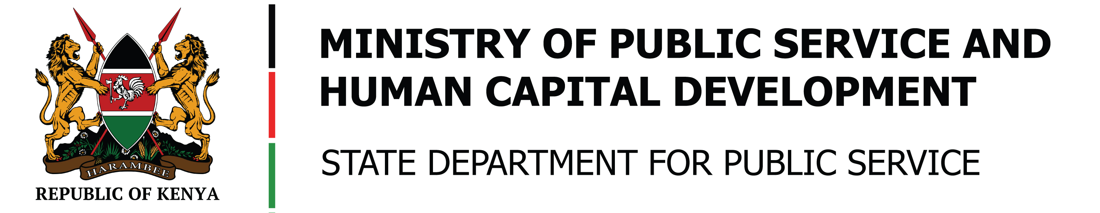

**SPEECH**

**BY**

**HON. JUSTIN MUTURI, EGH**

**THE CABINET SECRETARY, MINISTRY OF PUBLIC SERVICE, HUMAN CAPITAL DEVELOPMENT**

**DURING THE CABINET SECRETARY’S INAUGURAL VISIT TO HUDUMA KENYA SECRETARIAT OFFICES, HUDUMA CONTACT AND TELE-COUNSELING CENTRE AND**

**HUDUMA CENTRE, GPO**

**MONDAY, 7TH OCTOBER, 2024**

**Salutations;**

**Mr. Amos Gathecha,** Principal Secretary, State Department for Public Service, ndc (K),

**Mr. Ben Kai Chilumo,** CEO, Huduma Kenya,

**Mr. George Njao**, Director General (DG) of the National Transport and Safety Authority

Huduma Kenya Directors, the Huduma Centre Manager – GPO, Huduma Kenya staff,

And our esteemed customers present at the Huduma Centre.

**Ladies and Gentlemen,**

**Good morning,**

1. It is a great pleasure to officiate my first Customer Service Week at Huduma Kenya.
2. The Huduma Kenya Service Delivery Programme has **transformed** the **Public Service** to one that is **responsive** to the needs of Kenyans by making Government services **convenient, dignified** and **easily accessible**.
3. Currently, Huduma Kenya has 4 Service delivery platforms, that is the **57 Huduma Centres**, **Huduma Mashinani Outreaches**, **Huduma Contact and Tele-Counselling Centre**, and the **Huduma E-platforms**.
4. I applaud the collaboration with various **Ministries, Departments, Agencies** and **Counties**, for deploying services across these service delivery platforms and ensuring equal access to government services for all citizens.
5. I commend the Huduma Kenya staff for their **commitment** to **exceptional service delivery**. This dedication has made Huduma Kenya the **trusted face of the government**.

**The Customer Service Week**

**Ladies and Gentlemen,**

1. This week we join the rest of the world in celebrating our customers, under the theme **“Above and Beyond”**.As public servants, we must go above and beyond our call of duty in our service delivery to Wananchi.
2. Our role is not just to meet expectations but to exceed them, ensuring that every interaction with our citizens is marked with **compassion, courtesy, respect**, and **efficiency** leaving an unforgettable experience to our customers.
3. At Huduma Kenya, we acknowledge that **our staff** are the **custodians of the Huduma Culture** and are **the drivers of above and beyond service delivery**. We have organized a **multitude of activities** across the 57 Huduma Centres and the Huduma Contact and Tele-counselling Centre to **appreciate our customers** and also **recognize the staff** who have performed above and beyond our customers’ expectations.

**The Future**

**Ladies and Gentlemen,**

1. In line with the Kenya Vision 2030 and The Bottom-up Economic Transformation Agenda (BETA), Huduma Kenya envisions to **roll out 290 Sub-County Huduma Centres**. So far, in **collaboration with the NG-CDF** and **support of the** **local Members of Parliament**, we have operationalized **6 sub-county Huduma Centres** in Tharaka Nithi, Kajiado, Kiambu and Laikipia Counties.
2. To embody the One-Stop-Shop concept, I urge all Ministries, Departments, Agencies, and Counties to **deploy services** across the Huduma Centres to ensure equitable and seamless service delivery to citizens. I call upon those Ministries, Departments, Agencies, and Counties who do not have staff to **take advantage of the Huduma Kenya Universal Agent**. The Huduma Kenya Universal Agent shall be trained to offer various government services on the behalf of Ministries, Departments, Agencies and Counties.
3. Despite of having Huduma Centres in their Counties and some Sub- Counties, we note that citizens **still have to travel far distances** to access some government services that are not offered in their home County Huduma Centres. This is occasioned by **partial or non-deployment of these services** in all Huduma Centres. For instance, out of the 57 Huduma Centres, the National Transport and Safety Authority services are offered in only 15 Huduma Centres. Some citizens have to travel more than 200 kilometers to renew their driver's licenses or apply for new ones.
4. My Ministry will continue working closely with the relevant Ministries, Departments, Agencies, and Counties to **enhance availability of government services**. We have commenced talks with Director General of the National Transport and Safety Authority and we expect them to roll-out end to end services in the remaining 42 Huduma Centres in the near future.
5. Huduma Kenya has now revamped the Huduma Contact and Tele-Counselling Centre. The Centre now has an increased capacity to respond and handle more citizen queries. We, therefore, encourage all Kenyans to utilize the **Huduma Contact and Tele-Counselling Centre** for all information regarding government services. All you need is simply dial **1919** for comprehensive support and information, including **free counseling services**. You may not need to visit a Huduma Center in person.

**Ladies and Gentlemen,**

1. Despite the improved efficiency in processing government documents, there still lies **180,000 identity cards**, **47,000 driving licenses**, and **54,000 birth certificates** waiting to be collected by the owners in the various Huduma Centers across country. We, therefore, urge Kenyans to visit their Huduma Center and collect the documents they applied for.
2. Finally, ladies and gentlemen, together we can build a public service that is not only efficient but also **empathetic** and **responsive** to the needs of every Kenyan offering service with high customer service excellence.

**With those remarks, I would like to officially kick off the 2024 Huduma Kenya’s Customer Service Week celebrations.**

**Thank you.**

**God Bless you, God Bless Huduma Kenya, God Bless Kenya**